Nashville Buddhist Scholarship - by TNBuddhism.org

Introducing the new Nashville Buddhist Youth Scholarship! We want to encourage our teenagers and young adults to continue their education and continue to uphold Buddha’s teachings. We know college applications can be expensive, and want to help! Students are encouraged to apply for one or both of the categories, listed below:

Community Leaders Award (Senior Scholarship): For graduating high school seniors, this honor recognizes those with contributions to the Buddhist community and/or who will be inspired by Buddhist principles in the future.

Buddhist Education Award (Discovery Scholarship): For any students aged 13 – 25, this award will help pay for tuition and/or travel expenses to approved Buddhist retreats and continuing education programs at Buddhist institutes. (Note: All students can receive the honor as an accomplishment, but financial awards are preferentially given to families with larger need.)

As this is our first year, award amounts are yet to be determined, but will likely range around $250.

Applications are due by October 15, 2017. We are excited to hear from you!

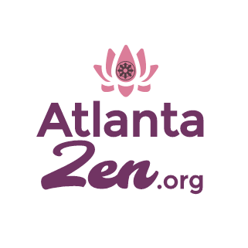
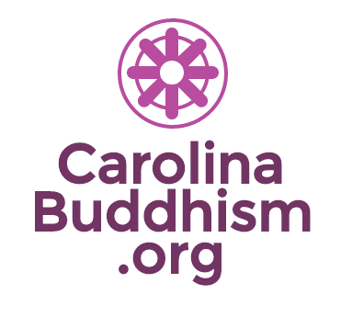
TNBuddhism.org In Partnership with:
Nashville Buddhist Scholarship by TNBuddhism.org
2017-2018 Academic Year Application

Part 1: Personal Information
Name:

Year of Birth:

Parent’s Name:

Parent’s Name:

Address:

Phone:

Email:

School:

School Address:

School Guidance Counselor or Scholarship Administrator Name and Email or Phone:

Grade/Year in School:

Cumulative GPA:

Please attach a copy of your transcript from your school.

(For information purposes only; e.g., USA) Country of Citizenship:
(For information purposes only; e.g., Vietnamese) Ethnicity:

Part 2: Community Participation History

Buddhist Temple, Meditation Group, or Buddhist Association you attend
Name of Center:
Phone Number:
Web site, if any:
Monk/Nun/Temple Leader name:
Email, if any:
(If you do not regularly go to any Buddhist center, please explain, in a short paragraph, why you are applying for this Buddhist Scholarship.)

Have you ever formally taken the Three Refuges (Triple Gem) or Five Precepts? (This is not a requirement, we are just wondering.)

How have you contributed to the Buddhist community? (Describe your activities at your temple.) If you have not been active in a group, then what is your personal Buddhist practice? (limit two pages maximum)

Part 3: Scholarship Specific Questions

Which Scholarship are you applying for? (please read detailed descriptions on website)
(Check one or both)
☐ Community Leaders Award (Senior Scholarship) – for graduating seniors only
☐ Buddhist Education Award (Discovery Scholarship) – for tuition/expenses for Buddhist coursework or retreat

For Senior Scholarship:
Please answer the following question, either in an essay, or in any format you wish, such as video, artwork, blog, website, social media, etc. (If not in essay format, please write a brief description and attach the file or link)
2017 Theme: How does Buddhism make you a better person?

(skip to Part 4 if not applying for the Discovery Scholarship)

For Discovery Scholarship:
- Please describe the Buddhist program you wish to attend, including date, tuition and estimated cost, if known. Currently, approved programs include the following below. If you are applying for a program not listed, please attach information, such as a web link and contact information, copy of a brochure, or other supporting documents. Support will only be given for programs that are run by non-profit Buddhist organizations, at the discretion of the Committee.
  - Georgia Buddhist Summer Camp, May 25 – 28, 2018 (www.georgiabuddhistcamp.com)
  - Overnight retreat program at Magnolia Grove Meditation Practice Center in Batesville, MS (www.magnoliagrovemonastery.org)
  - Overnight retreat program in California at City of Ten Thousand Buddhas or The Sudhanna Center, through Dharma Realm Buddhist University Extension (www.drbux.org)
  - Coursework or academic credit through Dharma Realm Buddhist University (www.drbu.org)
  - Coursework or academic credit through University of the West (www.uwest.edu)

- Financial Need
  - What is your total family (including both parents) annual income?
  - Does the program present a significant financial challenge for your family? (Please be honest. Answering no does not disqualify you.)
  - Do you or your family receive free or reduced school lunch or other government assistance program?
  - Are you or your parents refugees?
  - Are there any extenuating (special) circumstances we should know about?

- Please write, in 500 words or less, why you want to attend a Buddhist retreat?

Part 4: Conclusion

Names of applicants who are awarded a scholarship, and their essay or work, may be published.
☐ I give permission to have my name published.

Check here:
☐I affirm that the information provided in my application is accurate, and I will notify the Scholarship Committee of any changes in my plans or information. Honesty is a key value that I uphold.

Signature: (if on MS Word or PDF, type your name followed by the date)

Please email your completed application, including essays, to Meditate@GeorgiaMeditation.org by October 15, 2017. DOC, DOCX, or PDF formats are preferred.

